AI Assisted Coding End Lab Exam 20111.2025 AIB09 and AIB10

📘 SET 6

Question 1 (10 Marks):

Scenario: Write a Python function binary_search that implements the binary search algorithm on a sorted list. The function should return the index of the target element if found, otherwise -1. Use a zero-shot prompt to ask the AI to generate the code with clear, step-by-step comments explaining each part of the algorithm.
Include: docstrings, comments, and test cases.

Prompt: Write a Python function binary_search that implements the binary search algorithm on a sorted list. The function should return the index of the target element if found, otherwise -1. Use a zero-shot prompt to ask the AI to generate the code with clear, step-by-step comments explaining each part of the algorithm.

Code:

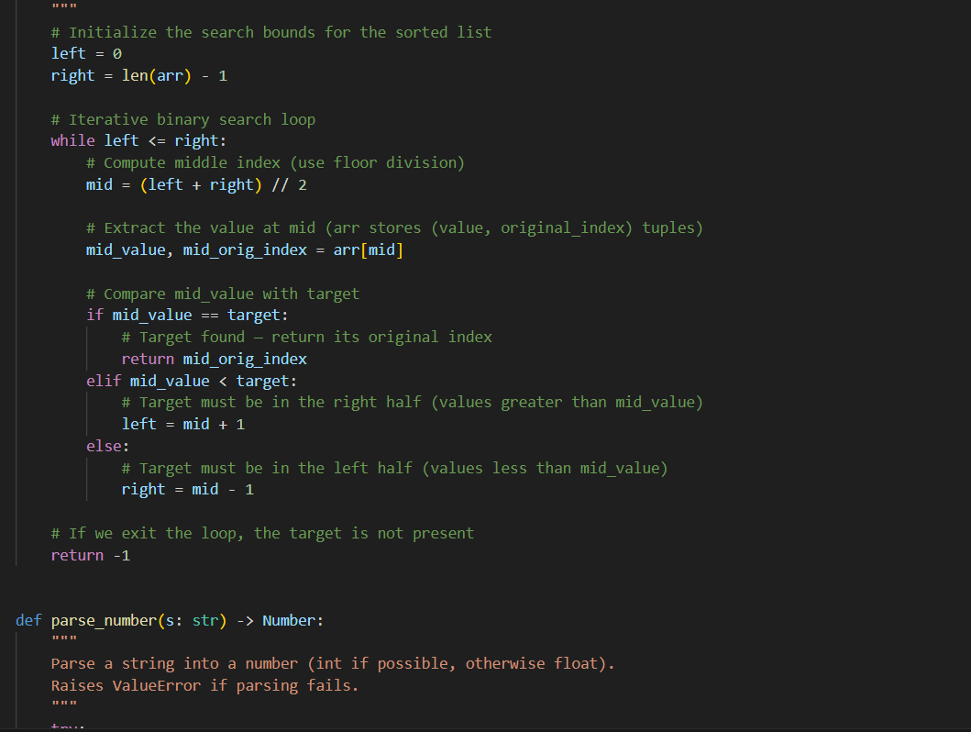
Testcases:
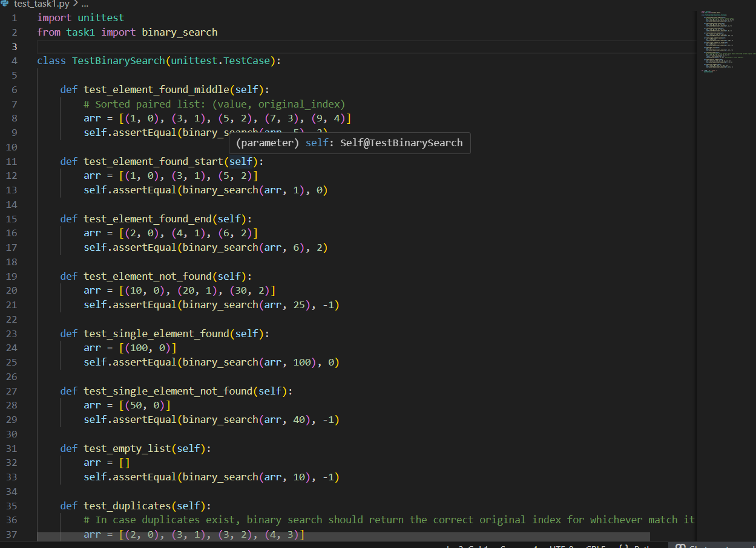
Output:
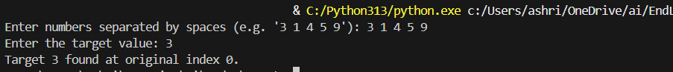
Include: docstrings, comments, and test cases

Question 2 (10 Marks):

Scenario: You are building a login system and need to validate passwords. Write a Python function validate_password that checks if a password string is at least 8 characters long, contains at least one digit, one uppercase letter, and one special character (e.g., !, @, #, $). Use AI to generate the conditional checks and regular expressions.
Include: docstrings, comments, and test cases.

Prompt: You are building a login system and need to validate passwords. Write a Python function validate_password that checks if a password string is at least 8 characters long, contains at least one digit, one uppercase letter, and one special character (e.g., !, @, #, $). Use AI to generate the conditional checks and regular expressions.

Code:

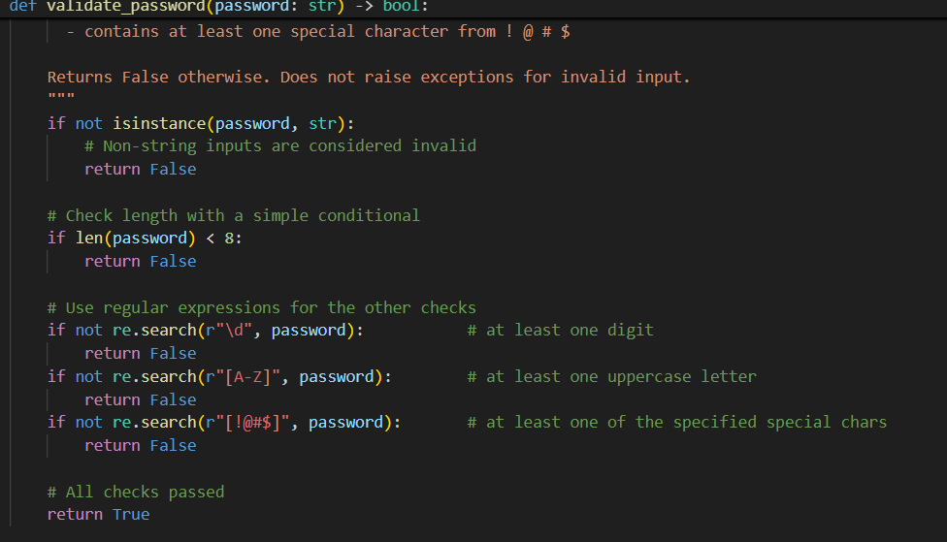

Testcase:

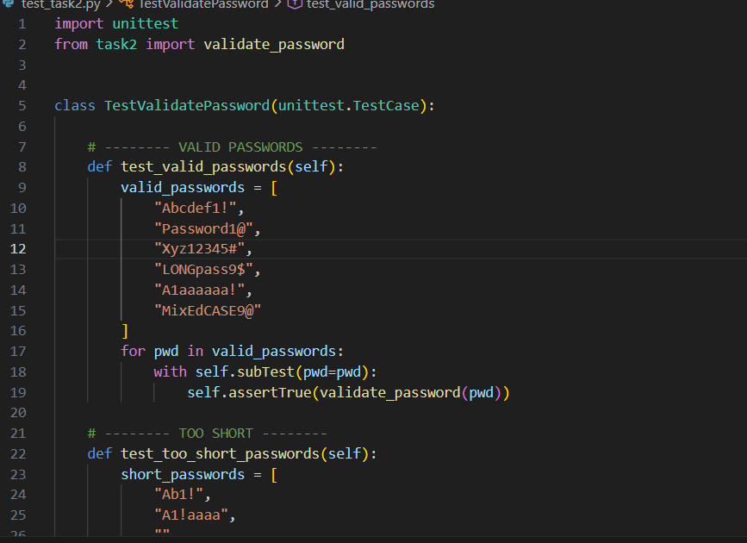

Output:

